Merging SAP PS with Microsoft Project

[**PhiB**](https://www.codeproject.com/script/Membership/View.aspx?mid=5123882), 6 Feb 2011

|  |  |
| --- | --- |
| https://codeproject.global.ssl.fastly.net/script/Ratings/Images/stars-fill-md.png  https://codeproject.global.ssl.fastly.net/script/Ratings/Images/stars-empty-md.png | 4.83 (5 votes) |
|  | |  |  |  | | --- | --- | --- | | Rate: | [vote 1vote 2vote 3vote 4vote 5](https://www.codeproject.com/Articles/43652/Merging-SAP-PS-with-Microsoft-Project) |  | |

Installation instructions for the CodeProject “Merging SAP PS with Microsoft Project”

* [**Download source - 1.65 MB**](https://www.codeproject.com/KB/install/MergingSAPPS_MSProject/Merging_SAP_PS_with_MS_Project.zip)

Prerequisites

* Microsoft Project Professional 2007 Client
* Microsoft Visual Studio 2008

Step by Step Installation Instructions

1. Unzip the “Merging SAP PS with Microsoft *Project.zip*” file to a working directory. This creates the “*Projects*” directory and sub folders listed below:

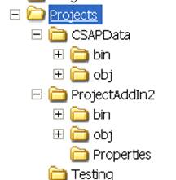

1. Run Microsoft Visual Studio 2008 and open *D:\Projects\ProjectAddIn2\ProjectAddIn2.sln*.
2. In the ProjectAddIn2 -> Properties -> Settings page, modify the settings to match your configuration:

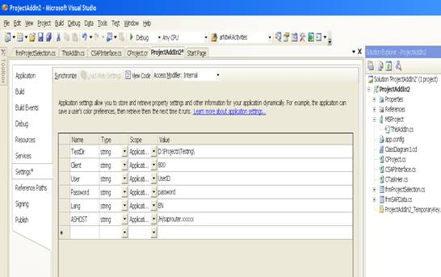

1. Make sure that the solution reference to CSAPData points to: *D:\Projects\CSAPData\bin\Debug\CSAPData.dll*.
2. Compile the project and run it.
3. A merged working copy of the selected SAP Project is saved to the “*TestDir*” listed above as a Microsoft Project *.mpp* file.
4. The *SAPProject.mpt* template file in the *TestDir* folder has our global constructs.
5. To recompile the *CSAPData.dll*, you must open the project in Microsoft Visual Studio .NET 2003. There is a reference article listed in the “CodeProject Merging SAP PS with Microsoft Project” document detailing how to do this.

Please feel free to send any questions or pointers to PBremner@bak.rr.com or go to [www.VisualSAP.net](http://www.visualsap.net/) and use the contact option (top center).

Sample project (which you don't have in your SAP system):

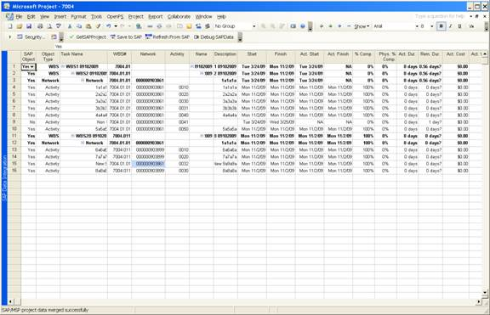

Alternative SAP Connection string:

Hide   Copy Code

String sConn = "CLIENT=" + Properties.Settings.Default.Client +

" USER=" + Properties.Settings.Default.User +

" PASSWD=" + Properties.Settings.Default.Password +

" LANG=" + Properties.Settings.Default.Lang +

" ASHOST=" + Properties.Settings.Default.ASHOST +

" SYSNR=" + Properties.Settings.Default.SYSNR;

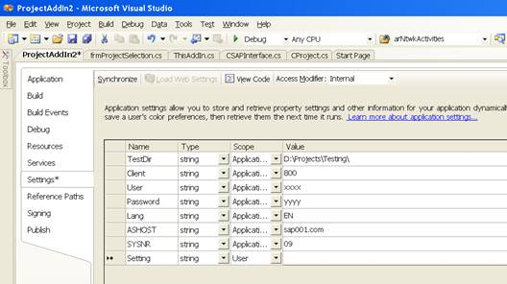

Running the Applet

This project updates or inserts a new Network-Activity (MSP Task) to/from SAP<–> Microsoft Project.

1. From Microsoft Visual Studio, run the project. You should get the following Microsoft Project screen. The status bar tells us the “SAP Addin loaded successfully”.

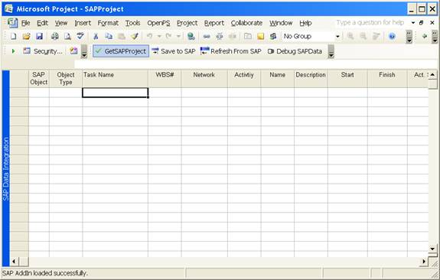

1. Click on the “GetSAPProject” button. This will log in to your SAP system and retrieve a list of available SAP projects. Select a project.
2. If the selected project (e.g. 7004) exists as an MSP *.mpp* file in the *TestDir*, the SAP Project and the MSP *.mpp* file are merged together.

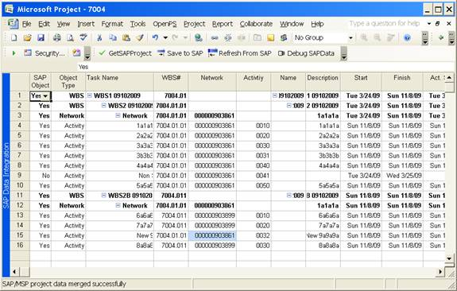

1. Let's insert a new Activity task and set the system to just move our new activity/task from MSP to SAP. We set the “SAP Object” field to “No” for all tasks except our new task. On task 17, we populate the:

Hide   Copy Code

SAP Object = "Yes" , our control field

Object Type = "Activity" , our control field

WBS# = "7004.001" , SAP field

Network = "000000903899" , SAP field

Activity = "0031" , we create, must be unique in SAP

1. Click on the “Save to SAP” button. Status bar says “Project saved to SAP successfully.

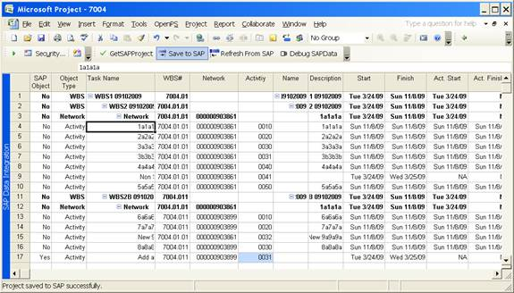

If you have any questions, email me at PBremner@bak.rr.com.

Thanks,   
Phil